The Articles of ISUS Alumni Association (recheck ver1.)

Article I. Organization

Section 1. Name
The name of the Association is “ISUS (International School of Urban Sciences) Alumni Association (hereinafter, the "Association")”.

Section 2. Objectives
The Association aims to:
- Promote friendship among its members;
- Share knowledge and information that its members may be interested in;
- Cooperate with the UOS Alumni to support the Association

Section 3. Activities
The Association shall carry out the following activities:
- Activities that will support the ISUS;
- Activities or projects that will facilitate close contact among the members and also between the members, the ISUS and foreign governments;
- Reunions;
- Other activities to achieve the goals of the Association

Section 4. Headquarter
The Association’s headquarter shall be located within the ISUS and branches established in Korea and overseas as necessary.

Section 5. Organization of the Association
Paragraph 1. Organization of the Association

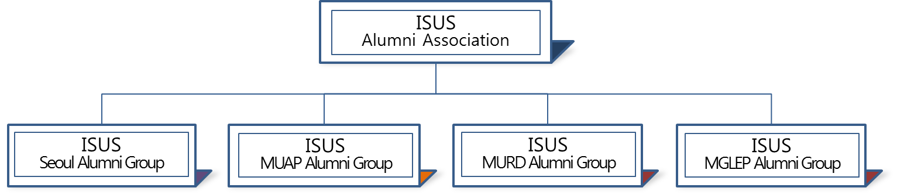

- The Association will be managed fundamentally in 4 different tracks as shown above.
- The whole management of Association should be under the control of the Association.

Paragraph 2. Organization of the Board
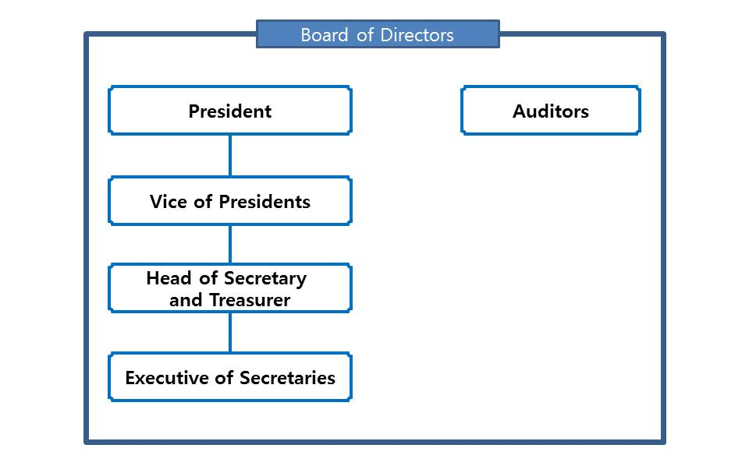

Article II. Membership

Section 1. Membership Categories
The Association’s memberships are comprised of the following categories:
  - Full membership
  - Associate membership
  - Honorary membership

Section 2. Membership Requirements
Paragraph 1. Full Membership
A full membership shall be granted to anyone who qualifies under the following categories:
- A Korean student who has received a graduate degree from ISUS, the University of Seoul);
- A MUAP or MURD or MGLEP student who has completed the coursework for one year at ISUS, the University of Seoul.

Paragraph 2. Associate membership
An associate membership shall be granted to current students of ISUS of University of Seoul (Korean, MUAP, MURD, MGLEP students)
Paragraph 3. Honorary membership
A honorary membership shall be granted to anyone who qualifies under the following categories:
- Any person who has worked as a staff of ISUS
- Any person who has worked as a faculty member of ISUS
- Any person designated by Board of Directors’ decision
Paragraph 4. Membership Approval
- Full membership and Associate membership could be granted automatically under the aforementioned circumstances;
- Awarding Honorary membership requires approval from the Board of Directors in advance.

Section 3. Rights of Members
Paragraph 1.Full membership
Anyone who has full membership title has following rights to:
  - Voting
  - Responsibility of the Organization
  - Participating in all meetings
Paragraph 2. Associate membership
Anyone who has associate membership title has following rights to:
- Suggesting opinion
- Participating in some events of the Association
Paragraph 3. Honorary membership
Anyone who has honorary membership title has following rights:
- Suggesting opinion
- Participating in some events of the Association

Section 4. Termination of Membership
The membership shall be expired:
- By voluntary resignation in writing
- By the termination or withdrawal of the application
- By death

Section 5. Full Membership Fees
Paragraph 1. Fee
The Association shall be managed on membership fees, donations, fund, and other revenue as follows:
- Korean Alumni
- Monthly fee (월회비) : 5,000 원

- Non-Korean Alumni (under MUAP and MURD) (To be discussed later)

Paragraph 2. Terms and Conditions
- The payment should be made within 1 month of the notice of payment
- Each dues payment shall cover the fiscal year of the Association, which is from January 1st to the following December 31st.
- If a member doesn’t pay the annual fee for two consecutive years, his/her right as a member will be suspended until the payment has been made.

Section 6. Meeting of members
Paragraph 1. General meeting
The General Meeting shall be held at a time and place to be determined by the Board of Directors at which time the election of Board of Directors shall take place. (See Article III, Section 4.)
Paragraph 2. Special meeting
Special meetings shall be held when called by the President or by the Board of Directors
Paragraph 3. Notice of meeting
Head of Secretary and Treasurer as directed by Board of Directors shall give notice of meetings.
Paragraph 4. Quorum
Each active member in good standing shall be entitled to one vote upon any matter presented to the Meetings. At meetings of the Association, 50% of members shall constitute a quorum of people who is entitled to vote. Voting can be done on-line.

Article III. Governing Body

Section 1. Board of Directors
The governing body of the Association shall be Board of Directors consisting of the elected members of the Association

Section 2. Duties of Board of Directors
The Board of Directors shall have full power to carry out the purposes of the Association, and shall have general charge and control of its affairs, funds, and property, but shall not have the sole right to amend the articles. It is responsible for setting immediate goals for the current administrative year and long-range goals for future Association achievement.

Section 3. Board of Directors
Paragraph 1. Board of Directors member
The members of the Board of Directors are as follows:
- President : one person (from Korean Alumni)
- Immediate Past President : one person
- Vice President(s) : three to six persons (from representatives of Korean Alumni / MUAP Alumni / MURD Alumni / MGLEP Alumni respectively)
- Head of Secretary and Treasurer : one person (from Korean Alumni)
- Executive Secretaries : three persons per year (from the students that represent the Korean Alumni / MUAP Alumni / MURD Alumni / MGLEP Alumni respectively)
Paragraph 2. Description of Duties
Duties of each position mentioned above as follows:
- President
The President, or in absence the Vice President(s), shall preside at all meetings of the Board of Directors. The President shall appoint all committees except as otherwise provided by the Articles, and perform such other duties as may be required by custom or by the welfare of the Association or by request from the Association including, but not limited to, the completion of the Association Annual Report forms.
- Vice President(s)
In the temporary absence of the president, the vice president(s) shall be designated by the president to exercise and perform his duties. At other times the vice president shall carry out such duties, such as presiding important committees of the Association, as may be delegated by the president to the Board of Directors and in charge of communicating with each alumni representative region.
- Head of Secretary and Treasurer
Head of secretary and treasurer should be in charge of the administrative and financial issues of the Association
- Executive Secretaries
The Executive Secretaries shall keep a record of all meetings of the Association and Board of Directors. The Secretary shall be the custodian of the records of the Association, conduct correspondence, and have charge of the membership and mailing lists. The Executive Secretaries shall notify all members of Association meetings and shall keep available for inspection by the Association members, copies of the Articles. The Executive Secretaries shall perform other duties of the Association and as assigned by the Board of Directors or president.

Section 4. Meetings of Board of Directors
- The Board of Directors shall meet at least twice a year to plan the activities of the Association and to oversee the Association situation in general, or at any time designated by the President;
- The Secretary will be responsible for notifying each member of the Board. At such meetings a majority constitutes a quorum
- The foreign member of Board of Directors may attend the meeting online.

Section 5. Elections
Paragraph 1. Nominating Committee of the Board
- The president, with the approval of the Board of Directors, shall appoint a nominating committee.
- The nominating committee shall present to a meeting of the Association called for that purpose a list of nominations for the positions of president, vice president(s), head of secretary and treasurer, executive secretaries, representative of Korean alumni, representative of MUAP alumni, representative of MURD alumni, representative of MGLEP alumni and any additional members of the Board of Directors. Nothing in the Articles shall prevent the nomination of members for any or all of these positions when properly made from the member.
- The nominating committee consists of three to five persons.
Paragraph 2. Election of the Board
- The election shall be held at a time designated by the Board of Directors (see Article II section 6).
- Newly elected board of director begin his/her term on January 1st;
- All of Board of Directors members except Non-Korean members shall be elected for a two years term, and shall not be re-elected more than two terms in a row.
- The election for Non-Korean members could be held each year.
Paragraph 3. Notification of Election Results
Notification of election results shall be transmitted at once to the Association members

Section 6. Auditors
- The auditors are in charge of the monitoring and supervision of the financial aspect of the Association, and the performance of the Board of the Association. The auditors have the right to oversee the annual report prepared by the Association.
- There should be two auditors (One from Korean Alumni and the other from MUAP Alumni or MURD Alumni or MGLEP Alumni)

Article IV. Fiscal Year
The fiscal year of the Association will be started from January 1st each year through the following December 31st .

Article V. The Amendments
These regulation may be amended, altered, or repealed at any general or special meeting of the Association by a fifty percent vote of those present, provided that notice of the proposed amendment, alteration, or repeal has been sent at least ten days prior to such meetings to all current Association members and provided the amendment, alteration or repeal is approved by Board of Directors of Association.

Article VI. The Regulations of each program of the Alumni Association
The regional alumni representative is the person who represents alumni from the continents that are part of the ISUS program. The regulations of each regional alumni representative of the ISUS program will be defined by the Board of Directors and should be finished after three months of the approval of this article.

Article VII. Regulation enactment and management
The financial and expenditure of Association fees rely on rule of separate operation and should be controlled by the Board of the Directors.
<Supplementary Regulations>
Article 1. The details that were not stated by this article follow general customs and practices.

This article prepared by Executive Committee and will be applied effectively from September 1st , 2017.

<Board of Directors of ISUS Alumni Association>

- President : Mr. In Choon Hwang
- Immediate Past President : N/A
- Vice President(s)
Representative of Korean Alumni 1st : Mr. Ji, Byung Oh,
Mr. Jea Jun Choi
Representative of MUAP Alumni : Not Yet Decided
Representative of MURD Alumni : Not Yet Decided
Representative of MGLEP Alumni : Not Yet Decided
- Head of Secretary and Treasurer : Ms. Sang Chul LEE, Hye Suk Back
- Executive Secretaries
Representative of Korean Alumni : Mr. Sang Chul LEE
Representative of MUAP Alumni : Not Yet Decided
Representative of MURD Alumni : Not Yet Decided
Representative of MGLEP Alumni : Not Yet Decided

Auditors
- From Korean Alumni : Mr. Won Jong Chae, Mr. Sung Joon Park
From MUAP or MURD or MGLEP Alumni : Not Yet Decided

