Master Thesis

Thesis Title

by
Si Rip Lee

International Urban Development Program
International School of Urban Sciences
University of Seoul

August 2022

Thesis Title

by
Si Rip Lee

A Master Thesis submitted to the International School of Urban Sciences of University of Seoul in partial fulfillment of the requirements for the degree of
Master of Sustainability and Environmental Policy

June 2022

Approved by
Ji Do Kim
Advisor

This certifies that the master thesis of
Si Rip Lee is approved.

Thesis Committee Chair: Ji Do Kim

Hong Gil Dong (Thesis Committee Member #1)

Kim Chul Soo (Thesis Committee Member #2)

International School of Urban Sciences
University of Seoul
June 2022
ABSTRACT
Lorem ipsum dolor sit amet, consectetur adipiscing elit. Fusce porttitor fringilla diam, ac semper magna sagittis vel. Praesent facilisis, diam nec fermentum commodo, nisl metus efficitur orci, et venenatis odio erat a justo. Fusce posuere odio luctus finibus sodales. Aenean feugiat molestie vulputate. Vestibulum iaculis vulputate nibh ac varius. Duis vehicula diam et sapien semper interdum. Pellentesque tincidunt, libero sit amet cursus finibus, eros ante maximus diam, quis ultrices purus eros quis risus. Phasellus venenatis metus vel nulla suscipit rutrum. Mauris nisl mi, aliquet sit amet eros nec, facilisis posuere dui. Suspendisse et tellus eget nibh mollis mollis vitae eget sem. Pellentesque sit amet molestie nisl, in lacinia metus.
Morbi sit amet finibus tortor, et rutrum felis. Aenean auctor mollis risus et mattis. Interdum et malesuada fames ac ante ipsum primis in faucibus. Integer egestas tempus finibus. Cras nulla dui, finibus ac sem quis, faucibus vulputate ipsum. Suspendisse lacinia molestie neque et iaculis. Praesent a laoreet massa. Maecenas pharetra malesuada orci eu efficitur. Pellentesque ac est nisl.

Keywords: Praesent Id, Tellus Eu, Magna Facilisis, Dignissim

Master Thesis

Thesis Title

by
Si Rip Lee

International Urban Development Program
International School of Urban Sciences
University of Seoul

August 2022
CONTENTS
1. INTRODUCTION 1
1.1 Background 1
1.2 Research Objectives 1
1.3 Scope 1
1.4 Significance of the Research 2
1.5 Organization of the Thesis 2
2. LITERATURE REVIEW 3
2.1 Defining Urban Transformation 3
2.3 Traditional Market Revitalization Program 3
2.3.1 Definition of Traditional Market 3
3. RESEARCH METHODOLOGY 4
3.1 Selection of case studies 4
3.1.1 Case Study No. 1: Jeonju, South Korea 4
3.2 Research Design 4
3.3 Data Validity 5
4. DATA ANALYSIS AND INTERPRETATIONS 6
4.1 Physical Improvement 6
4.1.1 Ownership 6
4.1.2 Physical Intervention 6
5 CONCLUSIONS 7
5.1 Recommendations 7
5.2 Conclusion 7
5.3 Recommendations for future studies 7
BIBLIOGRAPHY 8
초록 9
ACKNOWLEDGEMENT 10

LIST OF TABLES

Table 1: Indonesia: Growth of Grocery Retail Outlets and Sales 5
Table 2: A Comparison between Traditional and Modern Market 6

LIST OF FIGURES

Figure 1: Market Place Distribution 3
Figure 2: Historic Timeline of the Jeonju Nambu Market 5

INTRODUCTION

1.1 Background
Traditional market has an important role along with the existence of human beings in the world.
A massive grown number of market places as a response of dynamic trading and economy demands on a society sometimes runs unequal to the budget provision for physical maintenance of the market places building.

1.2 Research Objectives
The purpose of this research is to evaluate a new alternative method in implementing urban regeneration during a traditional markets revitalization project policy initiated by the Ministry of Trade of the Republic of Indonesia. This research is conducted towards a comparative learning on the successful precedents at the Cheongnyeon Market in South Korea and the Santa Market in Indonesia.

1.3 Scope
There are another models of urban transformation, for instance renewal, redevelopment, recovery, revitalization, recovery, framework, gentrification, and restructuring.

1.4 Significance of the Research
The research is expected to contribute the knowledge in the following aspects:

1.5 Organization of the Thesis
This thesis is divided into the following five chapters: Chapter 1 presents the introduction of the study.

2. LITERATURE REVIEW

2.1 Defining Urban Transformation
This chapter explains a review from literature highlighting the urban regeneration method to redesign an urban facility through local communities. The chapter presents the concept of urban transformation prior to the traditional market revitalization project.

2.3 Traditional Market Revitalization Program

2.3.1 Definition of Traditional Market
A market on this context as a traditional market is a place that has potential transaction among sellers and buyers for changes of goods' demands and supplies in an affordable purchasing power condition (Center of Indonesian Domestic Trading Policy, 2015).
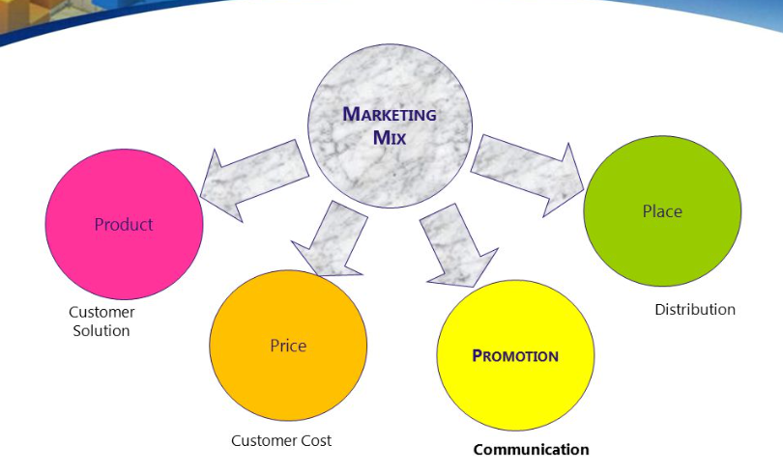
Figure 1: Market Place Distribution

3. RESEARCH METHODOLOGY

3.1 Selection of case studies
As it is explained in the title, this chapter includes the research methodology of the thesis. It informs the comparison study cases, source of data collection analysis, and the documents need to be reviewed.

3.1.1 Case Study No. 1: Jeonju, South Korea
Jeonju is located in Jeolla Province, south west part of the Korean peninsula. The city has stood for over 1,200 years, on the past time was a home for the Baekje Dynasty and the Jeoson Dynasty.

The Cheongnyeon Mall (Youth Mall)
From the year of 2008 to 2013, the Ministry of Culture, Sports and Tourism of the Republic of Korea initiated a major project to revitalize traditional markets well-known as the "Munjeong-seongshi" program.

3.2 Research Design
The research was conducted through document content, GIS base map, and location survey analysis. Several items of the documents are analyzed in comparison of two study cases in the Cheongnyeon Mall and the Santa Market are summarized in the tables below:

3.3 Data Validity
The research obtained comparative data and documentation between two cases study. Due to the time limitations, only a two similar study cases were conducted for this comparative research.

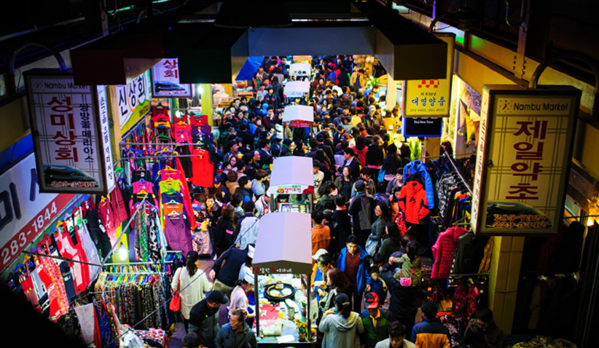
Figure 2: Historic Timeline of the Jeonju Nambu Market
Table 1: Indonesia: Growth of Grocery Retail Outlets and Sales
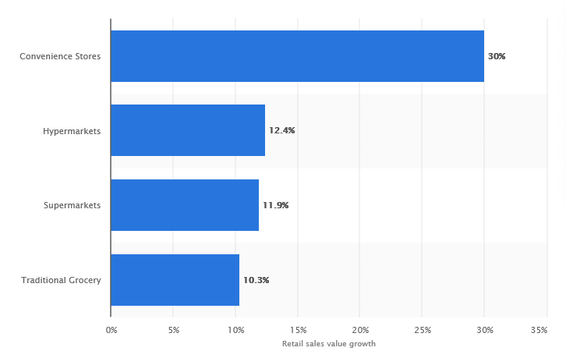

4. DATA ANALYSIS AND INTERPRETATIONS

4.1 Physical Improvement

4.1.1 Ownership
Both study cases of those traditional market buildings are state owned properties. Tenants paid for annual rent according to leasing space and the store position on a building layout.

4.1.2 Physical Intervention
The urban regeneration project in both case studies are physically intervened on the abandoned part of the building. The Cheongnyeon Mall initiated a physical intervention on the 2nd floor, the fired part of the Nambu Market building.
Table 2: A Comparison between Traditional and Modern Market
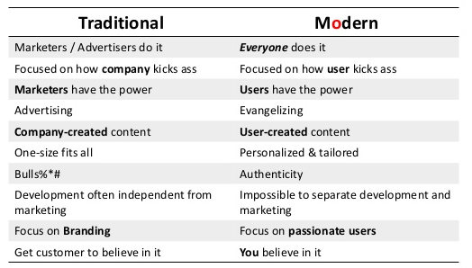

5 CONCLUSIONS

5.1 Recommendations
Based on the analysis and the objectives of this research, the following recommendations are proposed:
- The research explains that the role of communities initiates the urban regeneration projects.

5.2 Conclusion
By reviewing comparison of two urban regeneration project case studies, the research supported the promotion of urban regeneration, particularly on traditional market place.

5.3 Recommendations for future studies
The research was mainly an evaluation of urban regeneration project applied on traditional market place, in order to provide best practices for traditional market revitalization program.

BIBLIOGRAPHY
Dieter, C. A., Maupin, M. A., Caldwell, R. R., Harris, M. A., Ivahnenko, T. I., Lovelace, J. K., Barber, N. L. & Linsey, K. S. (2018). Estimated use of water in the United States in 2015 (No. 1441). US Geological Survey, (pp.26-33). (report)
Harzbecker, J. J. (1999), Life and deaths in Washington DC: An analysis of the Mortality Census data of 1850, Master's thesis, Oxford University, (pp.254-67). (Thesis/Dissertation)
Jayaprakasan, P., Uma, R. N., & Sankarasubramanian, A. (2018). Characterizing and Predicting Yelp Users’ Behavior. In Highlighting the Importance of Big Data Management and Analysis for Various Applications, Springer, Cham, (pp.17-35). (book chapter)
Mueller, U. R. (1992), Comparison of turbulence measurements with single, X and triple hot-wire probes. Experiments in Fluids, 13(2), 208-216. (Journal Article, 1 author)
PV Magazine (2018). Will Taiwan meet its 20 GW solar goal by 2025? Retrieved from: https://www.pv-magazine.com/2018/09/07/will-taiwan-meet-its-20-gw-solar-goal-by-2025/ (Date retrieved: 2018.9.27.) (online webpage)
Seo, S. B., Mahinthakumar, G., Sankarasubramanian, A., & Kumar, M. (2018a). Assessing the restoration time of surface water and groundwater systems under groundwater pumping. Stochastic Environmental Research and Risk Assessment, 32(9), 2741-2759. (Journal Article, 3 or more authors)
Seo, S. B., Mahinthakumar, G., Sankarasubramanian, A., & Kumar, M. (2018b). Conjunctive management of surface water and groundwater resources under drought conditions using a fully coupled hydrological model. Journal of Water Resources Planning and Management, 144(9), 04018060. (Journal Article, the same authors’ additional paper citation in the same year)
Stedinger, J. R., & Kim, Y. O. (2010). Probabilities for ensemble forecasts reflecting climate information. Journal of hydrology, 391(1-2), 9-23. (Journal Article, 2 authors)
The New York Times (2016) Think Like a Doctor: A Cough That Won’t Stop. Retrieved from: https://well.blogs.nytimes.com/2016/07/07/think-like-a-doctor-a-cough-that-wont-stop/ (Date retrieved: 2018.9.30.) (online news)
Turton, R. K., (1995), Principles of Turbomachinery, second ed., Chapman & Hall, London, (pp.55-56). (book)

초록
최근 전 세계적 동향과 역동적인 변화로 인해 도시 경관과 삶의 공간이라는 도시의 정의가 활동 공간(activities container)으로 재정립되고 있다. 한편, 도시의 급격한 변화를 따라갈 여력이 불충분한 사회 계층도 존재한다.

ACKNOWLEDGEMENT
This thesis writing process would not have been accomplished without the support and cooperation of several individuals and organizations. It is my pleasure to present my sincere gratitude towards them.

“This work is financially supported by National Institute of Environmental Human Resources Development of Ministry of Environment of Korea (KME) as 「Master’s Program for Future Global Leaders in Environmental Policy (MGLEP)」.”

