l
Program Information

2018 - 2019
UNIVERSITY OF SEOUL
Global Infrastructure Development Scholarship Program
(GIDSP)

Master of Infrastructure Planning & Development
(MIPD)

August 2018 ~ December 2019
Seoul, Republic of Korea

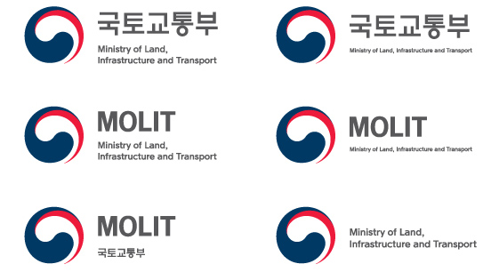 | 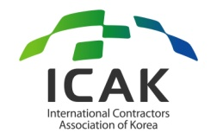 | 

CONTENTS

TABLE OF CONTENTS

PART 0. SCHOLARSHIP PROGRAM, MOLIT & ICAK 01
PART I. WELCOME MESSAGE 02
PART II. PROGRAM OVERVIEW 05
PART III. HOW TO APPLY 07
1. APPLICATION/ADMISSION PROCEDURE 07
PART IV. PROGRAM CONTENTS 09
1. ACADEMIC SCHEDULE 09
2. ORIENTATION 10
3. CURRICULUM 11
4. EXTRACURRICULAR ACTIVITIES 13
PART V. ACADEMIC INSTITUTION 14
1. GENERAL OVERVIEW OF UOS 14
2. INTERNATIONAL SCHOOL OF URBAN SCIENCES (ISUS) 15
3. ACCOMMODATION 16
4. OTHER INFORMATION 19
PART VI. SUPPORT SERVICE 26
1. TRAVEL TO KOREA 26
2. EXPENSES FOR STUDY AND LIVING 26
3. MEDICAL SUPPORT AND INSURANCE 27
PART VII. REGULATIONS 29
1. PARTICIPANT’S RESPONSIBILITIES 29
2. WITHDRAWALS 30
3. TEMPORARY LEAVE 30
4. ACCOMPANYING OR INVITING FAMILY 31
5. OTHERS 31
PART VIII. CONTACTS 32

Global Infrastructure Development Scholarship Program (GIDSP)

The Global Infrastructure Development Scholarship Program (GIDSP) funded by the Ministry of Land, Infrastructure and Transport (MOLIT) in Korea is designed to support Graduate Studies Program for government officials working in infrastructure development or related fields in partner countries of Korea.
The main goal of GIDSP is to support the training of key personnel who have the capacity to lead the sustainable physical development of Korea’s partner countries through the transfer of Korea’s know-how and experiences in infrastructure development.
The MOLIT launched the program with the International Contractors Association of Korea(ICAK), expecting to contribute to the capacity-building in infrastructure development of partner countries by allowing the participants to experience Korea’s development process, acquire specialized knowledge in the field of infrastructure and physical development through intensive training, and strengthen the ability for infrastructure planning & management.
The program will make its best effort to support participants of GIDSP not only in expanding their knowledge of infrastructure development, but also in establishing valuable networks with scholars and professionals in Korea while experiencing Korean culture, society and history.

Ministry of Land, Infrastructure and Transport (MOLIT) in Korea

The Ministry of Land, Infrastructure and Transport (MOLIT) was a cabinet-level division of the government of South Korea. The ministry was originally the Ministry of Construction and Transportation.
A country’s land should serve as a home for the people. Bearing this in mind, the ministry seeks more balanced territorial development with a focus on fostering innovation cities, along with other regions into real growth hubs. Through the so-called “New Deal for Urban Renewal”, the goal is to improve the quality of life, create jobs, and secure future growth engines.
The ministry also tacks abnormal business practices to create industry conditions that help promote the mutual sustenance between operators and workers, thereby sharpening the competitive edge for the industry and improving the quality of jobs countrywide.
With regards to transportation services, the ministry is committed to better serving the public interest. Rather than viewing the state-run institution only from a profitability-oriented perspective, the ministry emphasizes the fundamental value of the public services for the people.

The International Contractors Association of Korea (ICAK) was established in 1976 as the nation's only promotion agency for the overseas construction industry. The main function of the ICAK is to facilitate Korean contractors' overseas business and to develop the industry as a whole.
The ICAK assists its 836 member companies in exploring overseas market, developing projects, and negotiating contracts. It also works to increase cooperation and understanding between the Korean construction industry and those of other nations.
As the nation’s only think tank specialized in the overseas construction industry, the ICAK keeps abreast of important changes and developments in the world construction market. The ICAK also maintains important functions such as research & policy development, information service, plant project development & assistance, project appraisal & risk management, and education. In addition, the ICAK promotes bilateral and multilateral international cooperation, such as joint surveys on markets, information and personnel exchanges, and on-the-job training for developing countries.
International Contractors Association of Korea (ICAK)

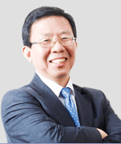
The Leading Education & Research Institution in Urban Sciences in Korea

Won, Yun-Hi
President, University of Seoul

The history of the University of Seoul is the history of Korea in view of social development. Since its establishment in 1918, the University of Seoul has changed its specialized area from agriculture, to industry in the 1970’s, and again to urban studies in the 1980’s. The University of Seoul has become more prestigious in recent years as it develops strategically Urban Studies. As the only university sponsored by the Seoul Metropolitan Government, the University of Seoul is leading the education and research in Urban Studies in Korea.
Urbanization becomes a crucial phenomenon now, and the developing world is where this drastic urbanization is occurring. For the first time, more than half of world population lives in cities. In particular, over 90 percent of urban growth is taking place in the developing world at the moment. Urbanization in the developing world was once considered unmanageable and hence restricted. However, the question is not how to constrain urbanization, but how to best prepare for it, maximizing the benefits of urbanization by promoting sustainable development while minimizing the negative externalities of urbanization such as congestion, crime, sprawling slums and environmental pollution.
The Ministry of Land, Infrastructure and Transport (MOLIT), the International Contractors Association of Korea and University of Seoul (MOLIT-ICAK-UOS) jointly offer a master degree program of infrastructure planning and management, especially designed for public officials from designated partner countries of Korea. It aims to enable public officials to enhance their ability to improve quality of their citizens' lives by providing world-class theoretical knowledge and Korea's practical experiences in infrastructure and territorial development.
The University of Seoul warmly welcomes all the participants of the MOLIT-ICAK-UOS Global Infrastructure Development Scholarship Program (GIDSP), pursuing the “Master’s Program of Infrastructure Planning & Development (MIPD),” and encourages all of you to keep your passion.

Thank you.
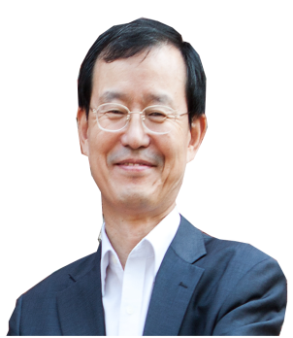

Hub of ‘International Networking’
for Global Experts

Han, Man Hee
Dean of ISUS, University of Seoul

The International School of Urban Sciences (ISUS) of the University of Seoul (UOS) was launched in Spring 2013 in an effort to contribute to the development of sustainable urban communities in the world through an interdisciplinary program of teaching, research, and outreach. ISUS offers two graduate programs in global construction management and sustainable urban & regional development. The two-year graduate degree programs seek to provide an interdisciplinary, engaged learning environment in which students from various fields acquire the knowledge and professional skills necessary for becoming leading practitioners in the field of construction and sustainable urban development .
In addition to the regular graduate programs, ISUS created the International Urban Development Program (IUDP) in cooperation with partner agencies and institutions in order to share Korea’s achievement in urban and regional development with scholars, government officials, and practitioners from the world. Each year, IUDP invites more than 50 government officials from Korea’s global partner countries for three master degree programs, Master of Urban Administration and Planning (MUAP), Master of Urban & Regional Development (MURD), and Master for Global Leaders in Environmental Policy (MGLEP).
Recently, ISUS has launched another graduate degree program, Master of Infrastructure Planning & Development (MIPD), sponsored by “Global Infrastructure Development Scholarship Program (GIDSP)” of the Ministry of Land, Infrastructure and Transport (MOLIT) in Korea and the International Contractors Association of Korea (ICAK) for government officials from designated partner countries. This newly sponsored graduate program is expected to contribute to sustainable development in developing countries by providing academic and professional skills necessary for working in the particular contexts of partner countries.
ISUS sincerely hopes that as many public officials as applicable in developing countries will take advantage of this valuable education opportunity.

Thank you.


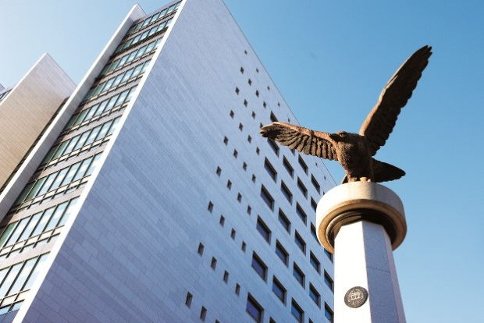
The University of Seoul was founded in 1918 and has provided higher education opportunities for the intelligent, motivated, and creative scholars. As a public institution, the University of Seoul is committed to addressing the social, regional, technological, and creative issues of the urbanized world. It has thus dedicated itself to cultivating leaders who will shape the urban future of Korea and the world. Its faculty, students, and administrative body are also distinguished by a commitment to civic values and a dynamic urban civilization.
The University of Seoul insists on quality and breadth. It is committed to both theory and practice, and endorses openness towards students and Korea's noticeable institutions. With more than 10,000 students enrolled, the University of Seoul consists of seven undergraduate colleges and almost 90 fields of study in the Graduate School. With diverse and specific programs that integrate research and policy, practice and education, the University of Seoul seeks a balance between academic and professional concerns, between visionary goals and practical research. Along with basic research, the University of Seoul functions as a think-tank in formulating and supporting the major policy goals of the Seoul Metropolitan Government.
In this sense, the International School of Urban Sciences has maintained a dominant position in a field of urban sciences. These range from environmental and civic engineering, architecture, urban planning and landscape design to public law and administration, taxation science, economics, urban sociology and management. With Korea’s largest and finest group of human and informational resources focused on the future of the world’s city, it boasts a unique array of research institutions working on the solutions to its problems and creative visions for its future.
University of Seoul,
The Birthplace of Korea’s Urban Study

Part II PROGRAM OVERVIEW

▣ Program Name: Global Infrastructure Development Scholarship Program (GIDSP)
▣ Degree: Master of Infrastructure Planning & Development (MIPD)
▣ Duration: August 01, 2018 ~ December 31, 2019 (17 months)
▣ Objectives:
- To provide future leaders of our partner countries with an opportunity to study graduate program on infrastructure development and related fields at a prestigious Korean university
- To enhance program participants’ knowledge and experiences in the field of infrastructure and national territorial development.
- To improve the program participants’ capacity to develop and manage public policies on planning the sustainable infrastructure
- To provide program participants with opportunities to develop cooperative relationships and personal networks with scholars, professionals, and government officials worldwide.
▣ Hosting Institution: International Urban Development Program (IUDP), International School of Urban Sciences, University of Seoul
▣ Language: English
▣ Cost and Financial Assistance: Full-ride scholarship with a monthly living allowance will be provided to cover the cost of attendance for the program. The cost of attendance includes the following:
- Tuition & Dormitory fees
- Economy class, round-trip airfare between Seoul and the participant's home country
- Monthly living allowance based on MOLIT guidelines
- Others to be covered : textbooks, medical checkup & insurance, official field trip expenses

▣ Application Eligibility
- Applicants must be a citizen of the Scholarship Program target countries.
- Applicants must hold a bachelor’s degree or the equivalent.
- Applicants must be a government official or a public sector employee whose work is closely related to infrastructure and physical development (three or more years of experience preferred).
- Applicants should be officially nominated or endorsed by his/her government.
- Applicants should have sufficient command of both spoken & written English to take classes conducted entirely in English.
- Applicants should agree to return to his/her home country on completion of study under this program.
- Applicants should be in good health, both mentally and physically, to stay in Korea for their program period.
- Applicants should be 45 years old or younger at the time of the application.
- Applicants should have not previously participated in a scholarship program (graduate program) supported by the Korean government.

Part III HOW TO APPLY

1. APPLICATION/ADMISSION PROCEDURE
a. Admission Procedure
- 1st Round : Evaluation of Application Documents
- 2nd Round : Phone Interview
Note: A phone interview will be conducted only for those applicants who have passed the 1st Round (Application Evaluation). The interview will be conducted in English.
b. Application & Registration Schedule

Procedure | Date
Application Due | May 18, 2018
Document Review | May 21 ~ May 25, 2018
Phone Interview | June 4 ~ June 8, 2018
Final Admission Decision | June 13, 2018
Arrival in Korea | August 01, 2018

※ Please note that the dates are subject to change. All dates are in Korean Standard Time (KST)
※ All forms and documents have to be submitted by both email and post of the above due date. And they first have to be submitted as electronic copies via email (mipd@uos.ac.kr). Please make sure that electronic copies cannot be replaced with original copies.
c. Application Requirements
All of the following application materials should be sent to University of Seoul (UOS) directly.
- Address : International Urban Development Program (IUDP)
International School of Urban Science (ISUS)
University of Seoul
163 Siripdae-ro, Dongdaemun-gu,
Seoul, Republic of Korea (postal code: 02504)

- Application Form (Form1)
- Personal Statement (Form 2)
- Statement of Purpose/Study Plan (Form 3)
- Two Letters of Recommendation (Form 4) One of the letters should be sealed and sent by the applicant’s current agency or organization. If necessary, one additional letter (the third one) can be written and mailed by a local Korean diplomatic office, a Korean business corporation, or its local branch located at the applicant’s residence
- Letter of Nomination from the Ministry or Organization of the applicant’s affiliation
- Copy of University and Graduate School (if applicable) Diplomas or official proof of prospective graduation with the confirmed date of graduation (Applicants must carry the original copies of the submitted diplomas to Korea if selected)
- Official Transcripts of undergraduate and graduate schools
- Official Report of English-Proficiency Test (TOEFL/TOEIC/IELTS) or any proof of applicant’s English-Proficiency
- The test results must be issued within two years from the application deadline.
- Certificate of Employment
- Curriculum Vitae
- A Copy of Passport (If the passport has yet to be issued, please send a photocopy of national ID card. As soon as the passport is issued, please send the a copy of the passport)
- Two photos, 3X4 cm or passport size

  Important Notes for All Applicants:
- All forms should be completed in English and all the supporting documents should be in English as well. Documents in any other language should be accompanied by a notarized English translation.
- Original documents should be submitted. Should they be unavailable, however, copies must be authorized by the originating institution before they are submitted.
- If any of the submitted materials contain false information, admission will be rescinded.
- Applicants whose forms and supporting documents are incomplete or unsatisfactory will be disqualified from the admission process.
- Applicants should take full responsibility for any disadvantage due to their mistakes or omissions in the application process.

Part IV | PROGRAM CONTENTS

1. ACADEMIC SCHEDULE

Semester | Academic Schedule
Arrival & Preliminary Session  (Aug 01-31, 2018) | Aug.1.-Aug. 15 | Arrival, medical check-up, settlement, OT
Arrival & Preliminary Session  (Aug 01-31, 2018) | Aug.16- Aug. 31 | Preliminary Session, Course Registration
1st semester  (Sep 1-Dec 21, 2018) | Sept. 1  Oct. 22 - Oct. 26  Dec. 17 - Dec. 21 | Beginning of Semester  Mid-term Exam  Final Exam
Winter Break  (Dec 25, 2018- Feb 28, 2019) | Dec.26 – Jan.19  Jan-Feb  Feb. 20 - Feb. 24 | Korean & English Class  Internship  Course Registration
2nd Semester  (Mar 2-Jun 21, 2019) | Mar. 2  Early April  Mid-April  Jun. 12 - Jun. 16 | Beginning of Semester (required credits: 17)  Comprehensive Exam  Mid-term Exam  Final Exam
Summer Break  (Jun 22-Aug 31, 2019) | Jun. 19- Jul. 14  From July  End of July | English & Korean Classes  Summer Internship  (Depending on the students’ interest & demand from host institutions)  Thesis Seminar (Thesis Proposal Presentation)
3rd Semester (Synthesis & Thesis)  (Sep 3-Dec 21, 2019) | Early November  Early December  Mid-December  Late-December  Jan. 21 | Interim Thesis Exam  Final Thesis Exam (Thesis Defense)  Thesis Submission  Program Completion Ceremony  Departure
Departure Period  (Dec. 22-Dec 31, 2019) |  | Departure
* The above schedule is subject to change. A detailed program schedule will be provided upon arrival.

a. Preliminary Session (2 Weeks)

Students are required to take a 2 week preliminary session before the first academic semester begins. The preliminary session is designed to help students adjust successfully to the program. Non-credit courses including Korean Language & Culture, Academic Writing will be offered during the session.

b. Regular Coursework Semesters (2 semesters)
Students are required to complete 30 credit hour coursework during regular academic semesters. During the Winter/Summer Session, an internship or job shadow opportunity would be offered to enhance the students’ practical understanding of urban and regional development. After completing the course work, students are required to pass a thesis submission qualification exam.

c. Synthesis & Thesis
After completing the first two semesters, students will be required to take a capstone project class to synthesize his/her learning throughout the program. Students are also required to write a Master thesis under the guidance of his/her advisor. Students will also be able to do an internship to enhance understanding of his/her major and support the thesis research process.

2. ORIENTATION

After arrival in Korea, an orientation will be held for the students. The orientation aims to provide participants with useful information on the program as well as general information on living in Korea that the participants will need during the program. The orientation will include:
- Introduction to the Global Infrastructure Development Scholarship Program (GIDSP)
- Introduction to the International Urban Development Program (IUDP) and UOS
- Overview of Academic Affairs
- Introduction of Student Support and Services
- A Seoul City Excursion
- Medical Check-up

(*) The medical check-up will be implemented after arrival in Korea to assure participants’ health condition. If any case including AIDS or pregnancy which may hamper their graduate study in Korea is found by the medical check-up, the participant will be required to return home. The acceptance to the GIDSP and the acquirement of the status of scholarship recipient will be confirmed after medical check-up.

3. CURRICULUM

a. Curriculum

The required coursework consists of 21 credit core coursework and 12 credit elective courses.
(*The courses are subject to change.)

Semester | Course Category | Course Title | Cr.
Preliminary Session | Language | Introduction to Korea | NC
Preliminary Session | Language | Basic Korean | NC
1st  Semester | Core | National Territorial Development Strategies & Systems | 3
1st  Semester | Core | Introduction to Infrastructure System | 3
1st  Semester | Core | Research Method | 3
1st  Semester | Core | Global Network Seminar Ⅰ | 2
1st  Semester | Electives  (1) | Infrastructure Financing | 3
1st  Semester | Electives  (1) | Construction Project Management | 3
1st  Semester | Electives  (1) | Transportation Planning | 3
1st  Semester | Language | Conversation in Korean | NC
1st  Semester | Language | Academic Writing | NC
Winter Session | Language | Conversation in Korean | NC
Winter Session | Language | Academic Writing | NC
Winter Session | Internship | Internship | NC
2nd  Semester | Core | Seminar on Public Private Partnership (PPP) | 3
2nd  Semester | Core | Thesis Seminar | 3
2nd  Semester | Core | Global Network Seminar Ⅱ | 2
2nd  Semester | Electives  (3) | Water Resource Development & Management | 3
2nd  Semester | Electives  (3) | Transportation Infrastructure Development | 3
2nd  Semester | Electives  (3) | Urban Infrastructure Development | 3
2nd  Semester | Electives  (3) | Energy Policy & Renewable Energy | 3
2nd  Semester | Electives  (3) | Climate Change Adaptation & Green Infrastructure | 3
2nd  Semester | Electives  (3) | ICT & Smart City | 3
2nd  Semester | Language | Conversation in Korean | NC
2nd  Semester | Language | Academic Writing | NC
3rd  Semester | Core | Capstone Project | 2
3rd  Semester | Core | Thesis Writing | NC

b. Required Grade Point Average (GPA)

- Students with a GPA below 3.0 for two consecutive semesters will be automatically expelled from the program.
- Minimum cumulative GPA for graduation within the 16 months of resident is B0 (3.0/4.5). Students with a GPA below 3.0 will be disqualified from acquiring a diploma or a graduation certificate.

c. Thesis Writing

- Prospective students are required to submit their policy research topics in the application process. An academic advisor will be assigned for the student based on his/her research topic once the student is admitted. The academic advisor will serve as the chair of the student’s thesis guidance committee.
- Each student should organize his/her thesis guidance committee in consultation with his/her academic advisor. The guidance committee should consist of 3 members including the academic advisor.
- The student must provide the members of guidance committee with a thesis proposal during the 2nd semester. The student will begin writing the thesis after approval of the thesis proposal.
- All students are required to submit their thesis to their guidance committee and the dean of ISUS at least a week prior to the defense date, and successfully defend their thesis by the end of the 3rd semester.

4. EXTRACURRICULAR ACTIVITIES

a. Field Studies

- Site Visits

The program will arrange a set of half-day site visits, which can help students to acquire more practical knowledge of Korea’s infrastructure development.
- Field trips

The program offers opportunities to learn exemplary practices such as Korea’s efforts to improve the major infrastructure development policy and practice in Korea.

b. Internship/Job Shadow Opportunities

The program will provide internship opportunities for the students to gain more practical knowledge of Korea’s infrastructure and national territorial development at cooperating public agencies or private corporations. The students will be able to do an internship/job shadow during the winter /summer break session or thesis writing session. Students who take advantage of this internship opportunity may take advice and collect data for capstone project and thesis writing from their internship institution.

c. Events

- Welcoming Ceremony and Orientation
- Home Visiting
- Sports Day
- Seminars, Forums, and Conferences
- Networking events such as Global Friends Night
- Cultural Events

Part V | ACADEMIC INSTITUTION

- GENERAL OVERVIEW OF UNIVERSITY OF SEOUL (UOS)
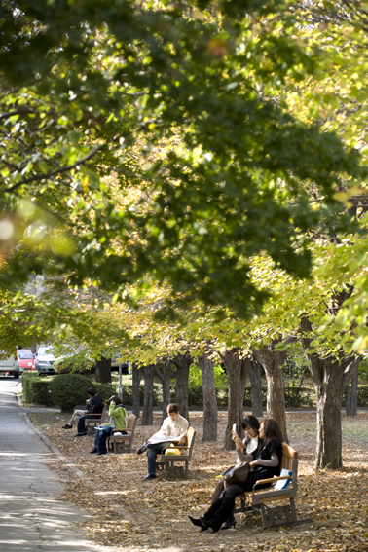
The University of Seoul is a public university funded and supported by the Seoul Metropolitan Government. Seoul is the economic, political, and cultural center of Korea. It is also the 600-year capital of Korea, a historical city with social, cultural, and physical layers spread out along a vast and complex landscape. The character of the university, academic programs, and research institutions is shaped by Seoul’s metropolitan dynamic. Its faculty, students, and administrative body are distinguished by a commitment to civic values and a dynamic urban civilization. Along with basic research, it functions as a think-tank in formulating and supporting the major policy goals of the Seoul Metropolitan Government. With diverse and specific programs that integrate research and policy, practice and education, the University of Seoul seeks a balance between academic and professional concerns, between visionary goals and practical research.
The University of Seoul has set a clear goal of becoming an international center for the urban sciences. These range from environmental and civic engineering, architecture, urban planning and landscape design to public law and administration, taxation science, economics, urban sociology and management. More recently, the university has diversified this base to include the arts and humanities. In the area of science and engineering, the university has concentrated on the development of information and media technology. With Korea’s largest and finest group of human and informational resources focused on the future of the world’s city, it boasts a unique array of research institutions working on the solutions to its problems and creative visions for its future.
For more information, please visit http://english.uos.ac.kr.

- INTERNATIONAL SCHOOL OF URBAN SCIENCES (ISUS)

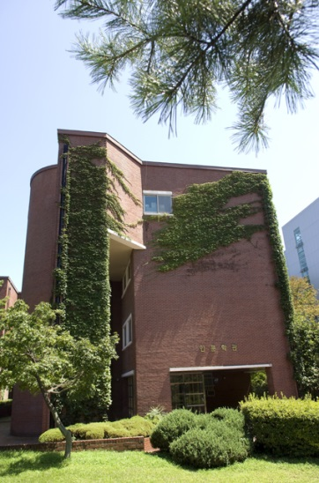
The International School of Urban Sciences (ISUS) of the University of Seoul (UOS) was launched in Spring 2013 in an effort to contribute to the development of sustainable urban communities in the world through an interdisciplinary program of teaching, research, and outreach. ISUS offers two graduate programs in global construction management and sustainable urban & regional development. The two-year graduate degree programs seek to provide an interdisciplinary, engaged learning environment in which students from various fields acquire the knowledge and professional skills necessary for becoming leading practitioners in the field of environment policy and sustainable development.
In addition to the regular graduate programs, ISUS created the International Urban Development Program (IUDP) in cooperation with partner agencies and institutions in order to share Korea’s achievement in urban and regional development with scholars and practitioners from the world. Currently, IUDP offers the Seoul Case Study Program in partnership with several world renowned public administration and public policy schools in the U.S., and England. The one-week field study program provides graduate students from partner universities with a unique opportunity to learn the best practices of Seoul in various urban administration and development areas. Each year, IUDP also invites about 20 government officials from Seoul’s global partner cities for a master degree program, Master of Urban Administration and Planning (MUAP). The MUAP program, sponsored by Seoul Metropolitan Government is designed for municipal government officials from Seoul’s global partner cities to acquire academic and professional knowledge and skills that can help them work for the special challenges their home communities have been facing with. ISUS developed another sponsored graduate degree program in Urban and Regional development (MURD) in partnership with the Korea International Cooperation Agency (KOICA) for government officials from KOICA’s partner countries. Recently, ISUS has developed Master’s program for Global Leaders in Environmental Policy (MGLEP), another sponsored graduate degree program, in partnership with the Korea Environmental Industry & Technology Institute (KEITI) for government officials from KEITI’s partner countries. These sponsored graduate programs are expected to contribute to the sustainable urban development in developing countries by providing the academic and professional skills necessary for their home countries.

- ACCOMMODATION
Students will reside in a single room either at International House or Guest House on campus. The university’s on campus housing facility, the Dormitory and International House has 190 rooms for male and 103 rooms for female students. Living on campus allows students to meet new friends and experience all that UOS campus offers through various living, dining, and campus life options.
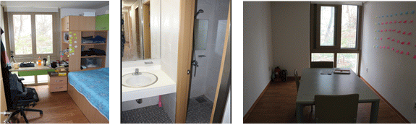
<Picture: Rooms in the International House>
All rooms are fully equipped with central heating, central air conditioning and free LAN internet access. Each occupant will use a single room but share a living room, shower room, toilet and laundry. The rooms are centrally air-conditioned but students can set the room temperature using the control switch. The electric voltage in Korea is 220V (60hz), and the standards wall socket has two rounded holes. Due to fire hazard reasons, the use of cooker, iron or coffeepot is strictly prohibited in the room. The International House has a community kitchen for students to cook their own food occasionally. Many international students use this community kitchen to cook their own ethnic food and share it with other international or Korean students.
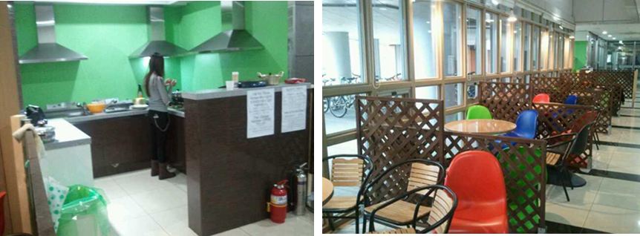
<Community Kitchen & Cafeteria>
The Dormitory and International House provides coin-operated laundry rooms and a gym for its residents’ use. These are located on the basement floor and open 24 hours. Seminar rooms, student lounges, and an internet café are also available for the residents.
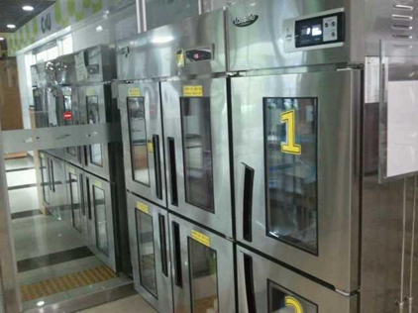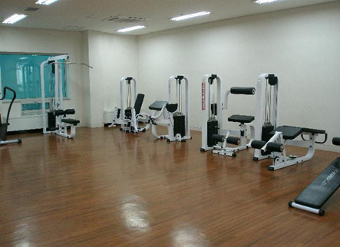
<Laundry Room and Gym>
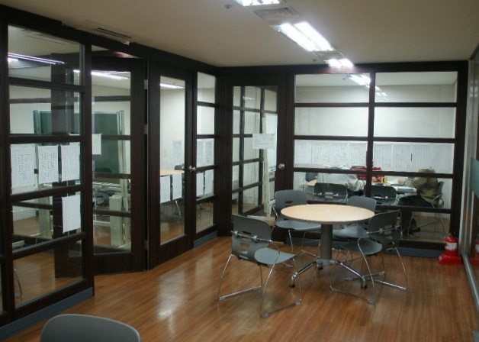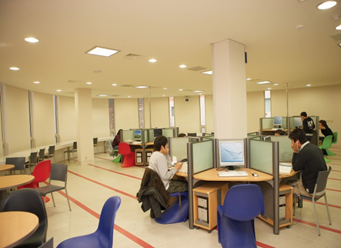
<Seminar Room and Internet Café>
• Certificate of Health All of the residents have to submit the certificate of health to the Dormitory Office. (Every participant has to take a medical check-up upon arrival in Korea. The medical check-up report may replace the certificate of health.)
• Dormitory Bedding Bedding and pillows are not provided; participants need to prepare their own blankets and pillows (Bedding materials can be purchased at the nearest store from school).
• Automatic Face Recognition System On your first day, you will have your photos taken at the dormitory office in order to be registered for dormitory access.
• Laundry You may do laundry after you buy a laundry card and charge it.
• Cooking Cooking is allowed at the Global Kitchen
• Residence Separation Each female and male dormitory is out-of-bounds from each other.
• Usage of Electricity The authorization of electric goods may vary as mentioned below. In case of using prohibited electric goods, the goods will be seized with penalty points imposed to the user.

Type | Goods | Allowed?: Yes or No
Heating equipment | Electric blanket | NO
Heating equipment | Electric linoleum | NO
Heating equipment | Electric heater | NO
Heating equipment | Fan heater | NO
Cooking equipment | Boiler | NO
Cooking equipment | Coffee maker | NO
Cooking equipment | Toaster | NO
Cooking equipment | Microwave | NO
Cooking equipment | Electric frying pan | NO
Cooking equipment | Gas burner | NO
Cooking equipment | Electric rice cooker | NO
Cooking equipment | Hot plate | NO
A/V equipment | VCR | NO
A/V equipment | TV | NO
A/V equipment | Electronic instrument | NO
Learning equipment | Desk lamp | YES
Learning equipment | Lap top | YES
Learning equipment | Printer | YES
Other equipment | Fan | NO
Other equipment | Refrigerator | NO
Other equipment | Mini air-conditioner | NO
Other equipment | Vacuum | YES
Other equipment | Hair dryer | YES
Other equipment | Mobile Charger | YES

* Kindly double check if your electronic goods are 220V-60Hz in case of fire or any electricity accidents.

- OTHER INFORMATION

- University Library
The University of Seoul Libraries are dedicated to serve for the academic success of all UOS community members. The UOS Libraries are composed of the main library and the following two branch libraries
- Law Library
- Economics and Business Administration Library
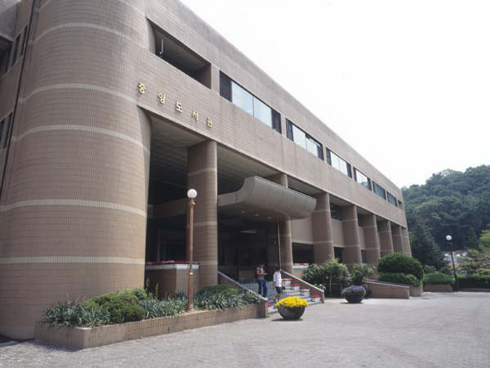
Main Library
The Main Library is composed of reading rooms with 2,200 seats and houses almost 800,000 volumes of books, monographs and references. It also holds 1,466 different periodicals, 58,034 units of non-book materials and several online databases.
The Main Library opened the Digitalized Information Service Room in 1998, which allows users to access more non-book materials.
The expanded and computerized library system enables users to confirm, check, renew, reserve, check-out, purchase and send orders via the internet. In 1999, the Main Library reached an agreement with the National Assembly Library for the mutual exchange of academic information through the internet, thus facilitating access to vast amounts of information.
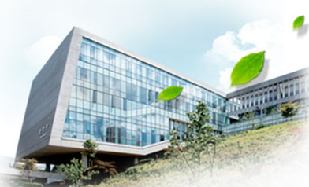
The Main Library also provides printing services for the full-text database of social science theses and dissertations. Most recently, the Main Library has created a new program which allows users better access to information on research resources, and has established the Integrated Retrieval System to facilitate easier access to multimedia data and e-books.
Law Library
The law library was established as a branch of the UOS Libraries with a legal resource room, a postgraduate reading room, and information retrieval equipment in Floors 4~6 on October 2008. The library has 80,705 legal books (as of January 13, 2011) in 1,600㎡ to support research activity, lecture, legal information investigation for the Graduate School of Law and legal area. On the 4th floor, it has group study rooms, an IT room, a laptop section and a lounge. On the 5th floor, it has a postgraduate reading room, an IT room and a preservation library. There is a legal study resource room including periodicals, reference books and articles on the 6 floor.
Economics and Business Administration Library
The economics and business administration library was established as a branch with reading rooms, group study rooms and seminar rooms in Floor 3 on March 2011. The library has over 20,000 books, 70 periodicals and 15 database in 1,036.8㎡ to support the research and learning activity of professors and students in management and economics. It has a 24 seat resource reading room, free reading rooms (148 seats), 5 study rooms (30 seats), a seminar room (8 seats), and information retrieval equipment (11 seats) to provide best service.

- Computing Facilities
Many computer labs are available in UOS. In Korea, IBM is more widely used than MAC. The most accessible places to the Internet are the Student Lounge on the first floor in the 21 Century Building and Main Library. If you bring a laptop, you can access the Internet in your dorm room with the LAN cable which you need to prepare by yourself.

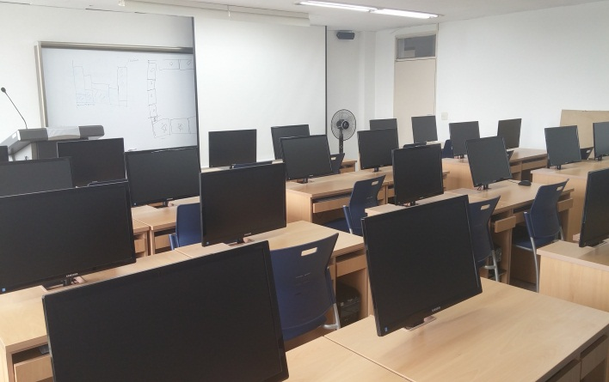
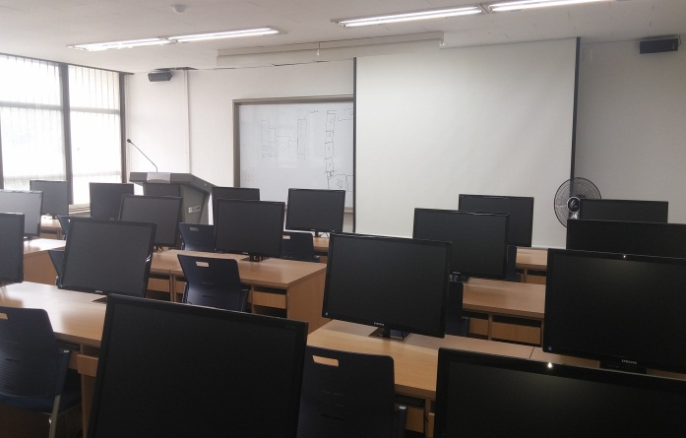
- ISUS Computer Lab ISUS has 24 computers readily available for classes.

< ISUS Computer Lab>

- Printer, Photocopy Machine and Scanner IUDP office is equipped with 3 computers, 2 printers, 1 photocopy machine and 1 scanner for students’ use.

- Bank and Money Exchange
Woori Bank is located on the first floor of the University Center Building. The business hours are from 9:00 to 16:00, Monday through Friday and it closes on weekends and holidays. During the preliminary session, students will fill out the application form to open a bank account.
Foreign currency can be exchanged into Korean currency (won) in banks at the airport, foreign exchange banks, and other authorized money exchange places including the on-campus Woori Bank. Please note that only US Dollars, Euros, Japanese Yens and Chinese Yuans can be exchanged on-campus bank. Global ATM can be found easily in Seoul. There is one right next to Woori Bank on campus.

- Student Cafeteria and Snack Bars
There are several cafeterias and snack bars on campus. They all serve different menus to meet the need of students and faculty.
  - Student Cafeterias
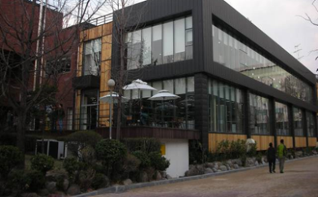
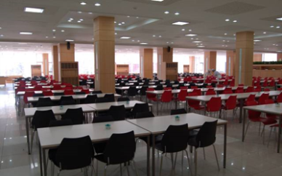
Student Cafeterias are located in the Student Hall, in the Natural Science Building and in the dormitory. Korean dishes and western dishes are available. Prices normally range from 2,000 won to 5,000 won per person and it subjects to the menu of the day. The cafeterias run from 8:00 to 10:00 for breakfast, from 11:00 to 14:00 for lunch, from 17:00 to 18:30 for dinner on weekdays and Saturdays, and are closed on Sundays.
  - Snack Bars
Several snack bars and cafes are also available in the Student Hall and other buildings on campus.
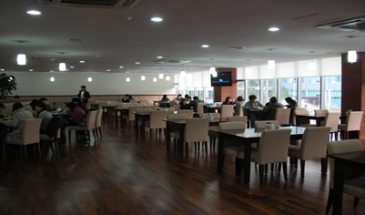
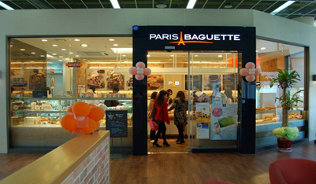
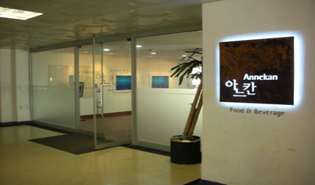

- Convenience Stores
Location | Floor | Convenience Store | Opening Hours  (during semesters)
Location | Floor | Convenience Store | Weekdays | Saturdays
Student Hall | B1 | CU | 08:00-22:00 | Closed
Main Library | B1 | CU | 08:00-22:00 | 08:00-22:00
Dormitory | 2 | CU | 07:00-01:00(+1) | 07:00-01:00(+1)
*Opening hours during vacation may differ from above.

- Student Cafeterias
Location | Floor | Cafeterias/  Restaurants | Menu | Opening Hours  (during semesters)
 |  |  |  | Weekdays | Weekends
Student Hall  (#12 on the map) | 1 | Student Cafeteria | Korean Meals | Breakfast 08:00-10:00  Lunch 11:00-14:00  15:00-17:00  Dinner 17:00-19:00 | Closed
Student Hall  (#12 on the map) | 1 | WEB | Fast Food | 09:00-19:00 | Closed
Student Hall  (#12 on the map) | 2 | Annekan | Western Style Meals | Lunch 11:30-13:30  Dinner 15:00-19:00 | Closed
Student Hall  (#12 on the map) | 2 | Café Hyu | Drinks and Desserts | 09:00-20:00 | Closed
Natural Science Building  (#8) | 1 | Student Cafeteria | Korean Meals | Lunch 11:30-13:30  Dinner 17:00-19:00 | Closed
Natural Science Building  (#8) | 1 | Café B | Drinks and Desserts | 09:00-19:00 | Closed
Law School  (#20) | 3 | Paris  Baguette | Bakery | 08:00-21:00 | Closed
Dormitory  (#22) | 1 | Student Cafeteria | Korean or Western | 08:00-22:00 | Closed

- Health Services
The University Health Service Center is located on the 2nd floor of the Student Hall. (Open from 9:00 to 18:00 except Saturday and Sunday) Examination, prescription and medicine for simple illnesses such as cold or indigestion will be offered without cost. On every Wednesday between 14:00~16:00 (exception of vacation), Campus physician is available.
- On Campus Health Services The University Health Service Center is located on the 2nd floor of Student Hall (#12 on the campus map). Examination, prescription and medicine for simple illnesses such as cold, indigestion and cuts will be treated free of charge.
- Office Hour: Mon.-Fri., 09:00-18:00(12:00-13:00, Lunch Break)

- Off-campus Hospitals
- Samyook Medical Center
Sundays & Weekdays: 09:00-17:00, Fridays: 09:00-12:00
- St. Paul's Hospital
Weekdays: 08:30-17:00(12:30-13:30, Lunch Break), Saturdays: 08:30-12:00

- Post Office
The post office is located on the first floor of the Student Hall. The campus post office provides general mailing services including mail, parcel, registration, domestic and international EMS, and certain banking services. The business hours are from 9:00 to 18:00 (to 16:00 for banking services).

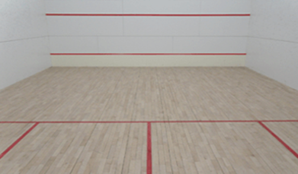
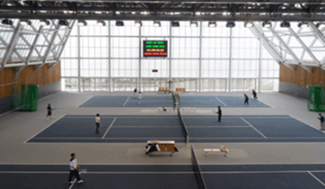
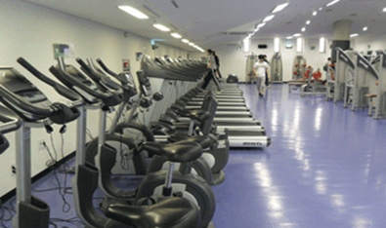
- University Gymnasium and Wellness Center
As a place for general physical education, the University Gymnasium and Sport Complex is used for instruction as well as for various sports and recreational activities. Various indoor and outdoor sport facilities and equipment are provided for such sports or recreational activities. The sports center has a fitness room and it costs 20,000 Won per a month. Some other facilities in the Gym include indoor tennis courts and squash courts.

- Wi-Fi Service
Wi-Fi service is available within the campus. In order to have access to it, students are required to create an ID and PW on the university website and log on to the mobile or laptop device with the log-on information. Preferentially, students may directly visit the Computational Intelligence Service Office.
- Office Hour: Mon.-Fri., 09:00-18:00 (12:00-13:00, Lunch Break)
- Location: 5th floor, University Center (#7 on the campus map)

- Student ID Card
The Student ID card is mainly used for library, entering the building, checking-out & returning books, etc. It will be ready for pick-up at the IUDP office from the second week of the semester.

- Foreigner’s Registration
All foreigners planning to stay in Korea for more than 90 days must report to the Seoul Immigration Office and register for the Alien Registration Card within 90days from the date of arrival. To be eligible for the Alien Registration, students should hold a long-term D-2 visa. Alien Registration will be done during the preliminary session and students will be accompanied by the program coordinator to the immigration office. It takes about a month to have the Alien Residence Card issued.
- Required documents:
- Alien Registration Form
- Certificate of Enrollment
- Passport
- 1 ID photo
- Registration fee: 30,000won (Fees may increase.)

Map of University of Seoul

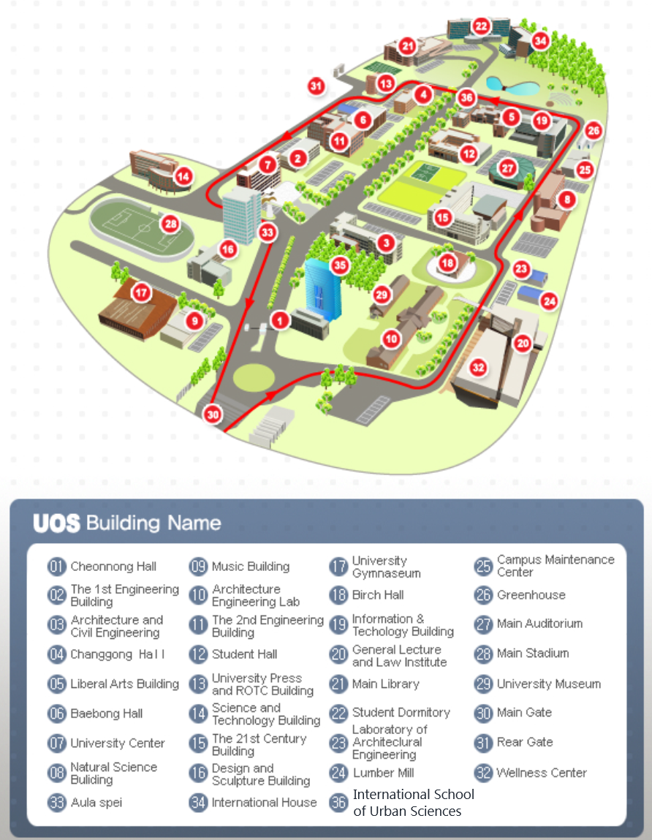

Part VI SUPPORT SERVICE

1. TRAVEL TO KOREA

UOS arranges and pays for the participant to travel to and from Korea. The participant is to travel by the most direct route between Incheon International airport and a main international airport in participant’s home country. UOS will cover economy class, round-trip airfare.

If a participant wants to change the flight itineraries, the additional fare should be borne by him/her. The participant is responsible for the issuance of a visa necessary for this Scholarship Program.

If a participant invites family members for a temporary visit during the program, he or she must take the full responsibilities for all the relevant costs and other necessary administrative procedures (please refer to the “4. Accompanying or Inviting Family” Section of Part 7. Regulations).

2. EXPENSES FOR STUDY AND LIVING

The following expenses will be covered by MOLIT-ICAK-UOS during the participant’s stay in Korea.

- Tuition & Dormitory fees
- Living allowance (including meals): KRW 999,000 per month
- Economy class, round-trip airfare between Seoul and the Participant's home country
- Miscellaneous travel expenses: KRW 200,000 upon arrival
- Others: A medical checkup after arrival, textbooks, field trip expenses

3. MEDICAL SUPPORT AND INSURANCE

    - Health Check-up
Health Check-ups will be provided two times throughout the duration of the program.
1st Check-Up: Upon arrival in Korea, in order to check the medical conditions before joining the Program.
If the medical check-up result shows that it is inadequate (i.e., pregnant, HIV-positive and other contagious diseases) for applicant to stay in Korea for a long time as a student, the acceptance to the program will be cancelled and the applicant will be is asked to return to his or her country.
2nd Check-Up: Medical Check-up for student health during the program. If the medical check-up result shows that it is inadequate for applicant to stay in Korea for a long time as a student (i.e., pregnant, HIV-positive and other contagious diseases), the acceptance to the program will be cancelled and the applicant will be asked to return to his or her country.
The 2nd check up will be conducted 6 months before student’s return to his or her country.
If the student wants additional check-ups, it the check-up fees will be borne by the student.

    - Insurance
National Health Insurance Program
The National Health Insurance Corporation (http://www.nhic.or.kr/portal/site/eng) provides health insurance for foreign students. The insurance is designed for overseas Koreans and foreigners who stay in Korea for more than a year. Foreign students, their spouses and their children under 20 are eligible for the insurance. To apply, the student must submit a copy of his/her alien registration card and verification of his/her purpose of stay at an office of the Corporation.
English call center service is available for foreign students at 02-390-2000.
Information of National Health Insurance
Type | Contents
Eligibility | - A foreigner who has intentions to stay in the Republic of Korea for more than one year with D-2(Student) Visa, and her/his spouse and children under 20 (F-3).  - A foreigner will be eligible to apply for the NHI after the Alien Registration certificate is issued.
Application Documents | - Verification of Eligibility including Alien Registration Card  - Verification of Purpose of Stay  (A copy of Alien Registration Card or a copy of Residence Certificate)  - Verification of Income (If the applicant has income)
Premiums | - The insured is subject to pay from the first day of Alien Registration  - The insured is subject to pay during temporary leave within 3 months.  - In the case of a temporary leave longer than three months, the insurance is cancelled on the next day of departure, and the student must renew it upon return.  - The payment amount is about 34,000 won monthly and must be prepaid in three month intervals.  * There is a 50% discount for students (D-2)
How to use the service | Same as Koreans
Payment | Prepaid per three months

    - Insurance Provided by the Institution
The details of the private insurance provided by the institution will be introduced during the course orientation upon arrival.

Part VII REGULATIONS

1. PARTICIPANT’S RESPONSIBILITIES

- Participants are required:

  - To abide by the rules of the academic institution
  - To take up the scholarship in the academic year for which it is offered (deferral is not allowed)
  - To reside in the accommodation designated by UOS for the duration of the course except for holidays or temporary leave
  - To maintain an appropriate study load and achieve satisfactory academic progress for the course. If the participant fails to attain certain grades required by UOS, his or her status as a GIDSP program participant may be suspended
  - To participate in all activities associated with the approved course of study including all lectures and tutorials, submit all work required for the course and sit for examinations unless approved otherwise by UOS in advance
  - To advise UOS of any personal or family circumstances such as health problems or family problems which may seriously affect their study
  - To refrain from engaging in political activities or any form of employment for profit or gain.
  - To agree to MOLIT or ICAK’s collecting information concerning them and passing that information onto other relevant parties, if necessary
  - To return to their home country upon completion of the program
  - Not to extend the length of the program or stay for personal convenience; neither MOLIT, ICAK nor UOS will provide any assistance and be responsible for an extension of their stay
  - To either return to their original job post or remain employed in a field related to their degree for at least 2 years.
  - If the participants break any of the rules of either MOLIT, ICAK or UOS during their stay in Korea, their status as GIDSP program participant may be suspended or terminated.
  - UOS may cancel the admission if a participant fails to take a medical check-up.

2. WITHDRAWALS

- In principle, a participant is not allowed to withdraw from the course at his or her own option once the course starts.
- A participant may withdraw with valid personal or other pressing issues from one’s home country (such as health or work issues) when acceptable to MOLIT-ICAK-UOS.
- If a participant fails to attain certain grades required by UOS, he or she may be forced to withdraw and return home upon withdrawal.
- The participant who withdraws must return to UOS the living allowance he or she has already received for the remaining period from the date of departure from Korea.

3. TEMPORARY LEAVE

- The number of days for possible temporary leave is not limited during vacation. However, participants are not allowed to have temporary leave to focus on study during semester in principle. In case of special circumstances e.g. his/her own marriage, death of family, participants can have temporary leave after they notify the university in advance. They should notify the Program Chair and the PSPS office prior to the departure by submitting the “Request for a temporary leave” document. The e-ticket should also be submitted when issued. This process is also applicable to those who want to take temporary leave during vacations. They should notify the Program Chair and the PSPS office in advance before departure by submitting the “Request for a temporary leave” and e-ticket.
- MOLIT, ICAK and UOS do not pay airfare for the trip. MOLIT or ICAK will not pay the living allowance for the absent days including departure date and arrival date.
- All expenses incurred for participant’s temporary leave should be covered by the participant, not by the MOLIT, ICAK and UOS.
- If the participant is found to have made an unreported temporary visit to his or her home country or traveled to other countries or made a trip without university’s approval, his or her living allowance will be suspended (from the day of departure to the day of return), and UOS may impose a disciplinary action on them, including expulsion from UOS.

4. ACCOMPANYING OR INVITING FAMILY

- As GIDSP Program is quite an intensive program which requires students of full commitment to and concentrated endeavors for study, participants are advised not to bring any family members.
- Participants may bring or invite family members within a month to the fullest under the condition that the Program Chair approves the invitation in advance. However, they must be able to cover all the relevant expenses such as airfare, accommodation, living cost, visa fee, insurance, etc. of their family as well as be responsible for any administrative procedures required

5. OTHERS

- MOLIT-ICAK-UOS will assume responsibility only within the limit and scope of the insurance for participants.
- MOLIT-ICAK-UOS is not liable for any damage or loss of participant’s personal property.

- MOLIT-ICAK-UOS will not assume any responsibility for illness, injury, or death of the participant arising from extracurricular activities, willful misconduct, or undisclosed pre-existing medical conditions.
- Participants are advised not to purchase or own personal vehicles due to safety concerns and concentration on their studies.

Part VIII | CONTACT

❏ International School of Urban Sciences (ISUS), University of Seoul

- Phone: +82-2-6490-5139
- Fax: +82-2-6490-5141
- E-mail: mipd@uos.ac.kr
- Home page: http://isus.uos.ac.kr/
- Address: #5-225, Liberal Arts Building, University of Seoul,
163 Seoulsiribdae-ro, Dongdaemun-gu,
Seoul, Republic of Korea (postal code: 02504)

