International School of Urban Sciences, University of Seoul

Format guidelines for a thesis written in English

Thesis Structure and Format
This guide covers key principles concerning thesis structure and format. These are largely based on the principles set out by University of Seoul (for a thesis written in Korean) but reflect a few adjustments and additions which were made in adapting to a thesis written in English. Advice on further details should be sought from thesis supervisors.
- Arrangement of the thesis
- Ordering

Preliminary documents
- Cover Page
- Statement of submission
- Committee Certification of Approval
- Abstract in English
- Title Page (The same as Cover Page)
- Table of Contents
- List of Tables, List of Figures, List of Illustrations (If applicable)

Main body
- Text (Main body of the thesis)

End matters
- References
- Appendix or Appendices, etc. (If applicable)
- Korean Abstract
- Acknowledgements (Personal acknowledgements optional, but include the official ones acknowledging the financial support from the scholarship provider)

- Formatting
Use font size and style that can ensure readability. Fonts such as Times New Roman or Arial are recommended. Refer to the following format guidelines for specific sections.
- Cover Page
- Use a larger font size, 22 point, for thesis title and the name of the Masters candidate; and 16 point for thesis subtitle.
- Thesis publication date appears at the end line of the cover page and includes the month and the year of thesis publication.
- Master’s degree candidates must use their full name as officially recorded at University of Seoul (including given name, middle name, if any, and surname).
- All items that appear on Cover Page should be centrally aligned, or ‘centered’.
- Refer to the following illustration for the physical layout of Cover Page.
3cm

7cm [Master Thesis] 7cm
2cm
Thesis Title
2cm
by
Your name

5cm

International Urban Development Program
International School of Urban Sciences
University of Seoul

February 2020
3cm

- Statement of Submission
- Statement of Submission should be provided in the format illustrated below.
- As with Cover Page, all items that appear on Statement of Submission should be centrally aligned.
- As with Cover Page, the month and the year of publication should be entered to indicate the publication date of the thesis.

3cm
3cm Thesis Title 3cm

by

Your Name

A Master Thesis submitted to the International School of Urban Sciences of University of Seoul in partial fulfillment of the requirements for the degree of Master of Urban Administration and Planning

February 2020

5cm 5cm
Approved by
Advisor’s Name
Advisor
3cm

- Committee Certification of Approval
A certification of thesis approval by the Thesis Committee should be produced according to the format illustrated below.

3cm
3cm This certifies that the master thesis of 3cm
[Your Name] is approved.

[Signature]
Thesis Committee Chair: [ Name]
[Signature]
[Name] (Thesis Committee Member #1)
[Signature]
[Advisor’s Name] (Thesis Committee Member #2)

5cm

International School of Urban Sciences
University of Seoul
June 2019
3cm

- Abstract
- Abstract in English should be placed immediately after Committee Certification of Approval as part of the preliminary documents; Abstract in Korean should be placed at the back as part of the End Matters (after References and, if any, Appendices).
- A set of carefully selected key words should be included at the end of the abstract.

- Page Numbering
- Title Page, Cover Page, Submission Statement, Approval Certification and Abstract are not numbered (No page numbers on the preliminary documents).
- Table of Contents, List of Tables, List of Figures, and List of Illustration are numbered in lower-case Roman numerals (e.g., i, ii, iii, vi, v, vi,…)
- The first page of the thesis text is page-numbered with Arabic number “1”, and all subsequent pages through the Acknowledgement are numbered with consecutive Arabic numerals. These include the pages containing tables and figures without text (without any words) within the main body of the thesis.
- Font size and spacing
- Use 11 point for Text and Abstract; 16 point for Chapter Title; 14 point for subheadings; and 9 point for footnotes. The font size for the rest of the thesis may be selected autonomously. Except for the purpose of creative expression, however, it is recommended to use the same font size and style throughout.
- Text should be 200% double-spaced. Exceptions may be applied to long quotations, footnotes, tables and table/figure captions.

- Table of Contents
  - Table of contents must include the main headings for Text, References, Appendix and Korean Abstract. The page numbers for all sections shown on the Table of Contents are right-justified and preceded by a dot leader.
Example:
Chapter 1. Introduction 1
Chapter 2 [Chapter Title] 10
1. [Subheading] 10
2. [Subheading] 30
Chapter 3 [Chapter Title] 80
Chapter 4 Conclusion 100
References 120
Korean Abstract 130

  - Either of the following hierarchical systems may be used to format chapters and sections.
Example 1:  Chapter 1 Introduction  Chapter 2  1.  2..  1)  2)  (1)  (2)  i)  ii) | Example 2:  1. Introduction  2.  1.1  1.1.1  1.1.2  1.1.2.1  1.1.2.2  1.1.2.2.1  1.1.2.2.2  1.1.2.2.2.1  1.1.2.2.2.2  1.1.2.2.2.2.1  1.1.2.2.2.2.2

2. Footnote Citations, References and Bibliography
A thesis must include a reference, or bibliography, section. This section may be entitled “Bibliography” or “References”. The bibliography should list materials which have actually been used, and therefore include the edition number for a book, except when the first edition is used, to enable verification of any quotations and citations used in the text. All references used in the text must be listed in the bibliography; and the bibliography should include only the materials which have been referred to in the text.

1) Footnotes in text
- Footnotes, which appear at the bottom of the page, are preferred to endnotes in principle. Use endnotes, which appear at the end of the chapter only when it is necessary.
- Footnotes must be numbered consecutively in Arabic numerals. When a very large number of footnotes is used, the numbering may be done by chapter (i.e., the first footnote of each chapter is numbered with “1”).
- Citations in footnotes are to be provided in the following manner.
- When a book is cited:
Enter the name of the author(s), the year of publication, the title of the book (in italics), publisher, publisher location, and the pages cited. The page numbers must be in round brackets.
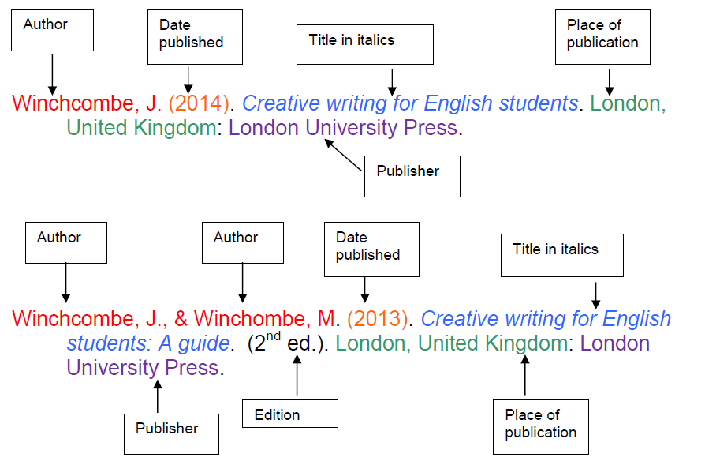
- Example: Turton, R. K., (1995), Principles of Turbomachinery, second ed., Chapman & Hall, London, (pp.55-56).
Dieter, C. A. et al. (2018). Estimated use of water in the United States in 2015 (No. 1441). US Geological Survey, (pp.26-33).
- (In the text) when the work cited is jointly authored by 3 or more authors, enter the first author's name followed by "et al.". Do not use et al. if there are fewer than three authors. However, in the bibliography, enter the entire authors’ name.
- Example: Johson, Honda, Rabe, & Chen, (2019) [in the bibliography] Johson et al., (2019) [in the text]
- When a dissertation or thesis is cited:
Enter the name of the author, the year of publication, the title of the thesis (in italics), degree level, the name of the academic institution, and the pages cited.
- Example: Harzbecker, J. J., (1999), Life and deaths in Washington DC: An analysis of the Mortality Census data of 1850, Master's thesis, Oxford University, (pp.254-67).
- When a journal articles is citied, it is particularly important to provide the journal title (in italics) and the volume number (Include the issue number in brackets, if available,).
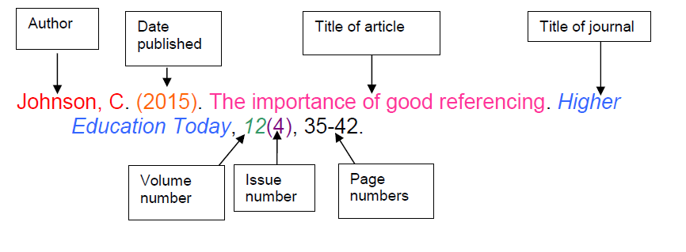
- Example: Mueller, U. R., (1992), Comparison of turbulence measurements with single, X and triple hot-wire probes. Experiments in Fluids, 13(2), 208-216.
- If more than one pieces of written work authored by an author or an authoring team in the same year are cited, distinguish them by adding lower-case letters “a, b, c” and so on.
- Example: Seo, S. B. et al. (2018a). Assessing the restoration time of surface water and groundwater systems under groundwater pumping. Stochastic Environmental Research and Risk Assessment, 32(9), 2741-2759.
Seo, S. B. et al. (2018b). Conjunctive management of surface water and groundwater resources under drought conditions using a fully coupled hydrological model. Journal of Water Resources Planning and Management, 144(9), 04018060.
- When a Website is citied,
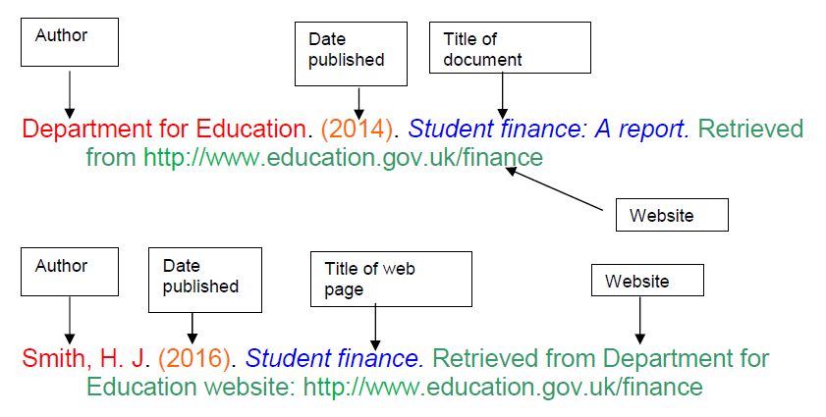
- Example: PV Magazine (2018). Will Taiwan meet its 20 GW solar goal by 2025? Retrieved from: https://www.pv-magazine.com/2018/09/07/will-taiwan-meet-its-20-gw-solar-goal-by-2025/ (Date retrieved: 2018.9.27.)
- When citing a source which has been cited earlier (and the full citation of which has been provided), an abbreviated form may be used.
i) If the source has been cited in the immediately preceding footnotes, merely enter “ibid.” followed by the page numbers (i.e., no author name or publication year).
- Example:
[1] Y. Anzai and H. A. Simon. The theory of learning by doing. Psychological Review, p. 126
[2] Ibid. → exact same source and same page as the previous citation
[3] Ibid. pp.20-21 → same source as the previous citation, but different page
ii) If the source has been cited earlier in full in a consecutive set of footnotes, enter the name of the author, year of publication, followed by “op. cit” before indicating the page numbers.
- Example:
[1] Y. Anzai and H. A. Simon. The theory of learning by doing. Psychological Review, p. 126
[2] Ibid. pp.20-21
[4] Herring, B. “Discounts for Honesty,” New York Times, March 9, 1997.
[5] Y. Anzai and H.A. Simon, op. cit., pp.50-51.

2) Citation in text and in the reference list
(1) All source items cited in text must be included in the reference list.
(2) Reference list (“References” or “Bibliography”) must be provided in the style consistent with the footnote citation style indicated above.
(3) When indicating a source in text, use brackets and enter the surname of the author(s) and the year of publication.
- Example: ….. (Gordon and Richardson 1989).
- When indicating a source authored by two or more authors in text, enter the surname of the first author followed by “et al.” in brackets.
- Example : ….. (Fone et al. 2013).
- In the reference section that follows the thesis text (under the section title “References” or “Bibliography”) references are listed in alphabetical order. Sources written in Korean or other languages should be translated in English but their original citation details (in the original language) should also be provided. When necessary, the reference section may be divided into subsections to list conventional sources and web sources separately; or to list English sources and other sources separately.
- When listing a Western author, enter the surname first followed by a comma (,) and then the initials of given name.
- Example: Kevin Lynch Lynch, K.
- When listing a Korean author, enter the surname first immediately followed by the given name being consistent with the Korean convention. If a separate section for Korean sources is provided, list them in the order of ‘가나다…’.
- Example: 김영욱, 1989, ……
- When listing a Chinese or Japanese author, use Chinese characters to indicate the author name and arrange them in alphabetical order according to local pronunciation.
- For further specific citation matters not covered in this document, please refer to author guidelines for major social science journals. There are alternative referencing styles which are acceptable. The key is to use a widely accepted academic style and be consistent throughout. University of Seoul citation guidelines are generally in line with the Harvard Style.

3) Other matters
(1) Tables, figures or other illustrative materials should be placed within the text, at a location near the corresponding text (i.e., where the table is referred to).
(2) If there are two or more appendices, classify them alphabetically using upper-case letters, such as Appendix A, Appendix B, etc..
(3) Tables and figures should be numbered in a consistent manner, such as Table 1-1 or Figure A.1.
(4) Acknowledgement should be at the end of the thesis.

Acknowledgement

Statement for MUAP:
“This thesis was financially supported by the Seoul Metropolitan Government under the International Cooperation Fund-ODA.”

Statement for MGLEP:
“This work was financially supported by the Korea Ministry of Environment and the National Institute of Environmental Human Resources Development (NIEHRD).”

Statement for MIPD:
“This work was financially supported by the Korea Ministry of Land, Infrastructure and Transport and the International Contractors Association of Korea (ICAK).”

Statement for MURD:
“This work was financially supported by the Korea International Cooperation Agency (KOICA) as part of the KOICA Global Fellowship Program (CIAT).”

Nine things you must remember to avoid having your thesis returned by the UoS Library after your departure from Korea (i.e., there is no one who can correct your mistakes, and the Library would not accept your thesis without correcting them).
The following items reflect 9 most frequently made mistakes.
1. Paper Size: Use 18.5cm×25.5cm.
2. Table of Contents:
Create ‘Table of Contents’ , ‘List of Tables’, ‘List of Figures’, etc. automatically using the relevant functions in MS-Word. If you are not familiar with the automatic table of contents, for instance, please ask your classmates who know how to use it for help.
3. Make sure that the Table of Contents starts with Chapter 1.
*Example:

Table of Contents

Chapter 1. Introduction···························· 1
Chapter 2. [Chapter Title]························· 10
4. Size of Illustrations: Make sure that the illustrations (graphs, tables, pictures, etc.) fit the paper size.
5. Korean Abstract:
A translation service company will be hired to have your abstracts translated. That takes place when you are at the very final stage of your thesis writing; i.e., when you have successfully passed the final examination and the content of your abstract has been duly confirmed by your advisor.
6. Acknowledgements:
Even if you do not intend to write any personal ‘Acknowledgements’, you need to include the acknowledgement page and enter the words of recognition at the end of the page as the following:
Statement for MUAP: “This thesis was financially supported by the Seoul Metropolitan Government under the International Cooperation Fund-ODA.”
Statement for MGLEP: “This work was financially supported by the Korea Ministry of Environment and the National Institute of Environmental Human Resources Development (NIEHRD).”
Statement for MIPD: “This work was financially supported by the Korea Ministry of Land, Infrastructure and Transport and the International Contractors Association of Korea (ICAK).”
Statement for MURD: “This work was financially supported by the Korea International Cooperation Agency (KOICA) as part of the KOICA Global Fellowship Program (CIAT).”

7. Page Numbering:
① Title Page, Cover Page, Submission Statement, Approval Certification and Abstract are not page-numbered (No Arabic page numbers on these preliminary documents).
② Table of Contents, List of Tables, List of Figures, and List of Illustration are numbered in lower-case Roman numerals
③ The first page of the thesis (Chapter 1) is page-numbered with Arabic number “1”.
8. Year: (e.g., if you graduate in February 2020)
① Cover Page: February 2020 (the month & year of the degree conferment)
② Statement of Submission: December 2019 (the month & year of the final defense)
③ Committee Certification of Approval: December 2019 (the month & year of the final defense)

9. Refrain from including additional stuff that is not instructed in the guideline. Do not put the UOS emblems, headers, footers, etc. in your thesis.
No UoS emblems, please!

